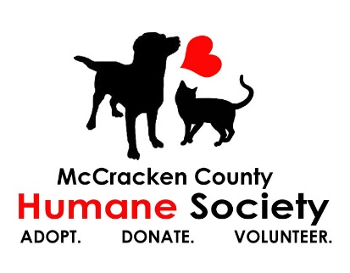
Youth Volunteer Application

DATE OF APPLICATION_______________

NAME_______________________________________BIRTHDATE________________________
ADDRESS______________________________________________________________________
CITY_____________________________________________ZIP___________________________
PHONE__________________C/P________________E-MAIL_____________________________
SCHOOL NAME______________________________________GRADE LEVEL________________
DRIVER’S LICENSE # ____________________________
EMERGENCY CONTACT:
NAME_______________________________________RELATIONSHIP_______________________________
HOME PHONE_____________________________WORK PHONE___________________________________
CELL PHONE_______________________________HOSPITAL CHOICE________________________________

*Do you have any allergies that might affect your work at MCHS? __________________________________
*Date of last tetanus inoculation______________________ (Attach a copy to application)
*Do you have any family or friends that are working here currently? YES ___ NO ___ If so, whom_________
What is your preferred day/time to volunteer? ____________________

Please tell us about the companion animals in your life and where they came from (shelter, pet store, etc.) __________________________________________________________________________________________
What extra-curricular activities do you participate in? _______________________________
Why do you want to volunteer at the McCracken County Humane Society? ____________________________ __________________________________________________________________________________________Have you ever volunteered your time elsewhere? If so, where? ______________________________________
How do your parents/legal guardians feel about your interest in volunteering at MCHS? __________________ Will you have consistent transportation to and from MCHS on the days you volunteer? ___________________
I confirm that all of the information supplied on this application is true and correct.

Teen Signature_________________________________________ Date____________________
Parent/Guardian Signature_______________________________ Date____________________

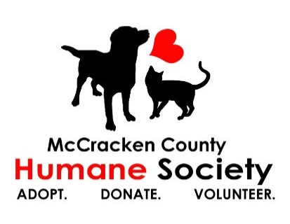
YOUTH VOLUNTEER RELEASE FORM

My son/daughter, ________________________________, hereby agrees to accept a position as a volunteer worker for the McCracken County Humane Society, hereinafter referred to as MCHS, and in so doing, he/she agrees to comply with all of the rules and regulations which may be established from time to time by MCHS. He/she understands that failure to do so may result in immediate termination as a volunteer.
My son/daughter acknowledges that his/her services are provided strictly on a volunteer basis, without any pay or compensation of any kind and without liability of any nature on behalf of MCHS. All services performed are at his/her own risk.
My son/daughter recognizes that in handling animals and performing other volunteer tasks there exists a risk of injury including physical harm caused by the animals. On behalf of my son/daughter, his/her heirs, personal representatives and executors, I hereby release, discharge, indemnify and hold harmless MCHS, its agents, servants, and employees from any and all claims, causes of action, or demands, of any nature or cause, including costs and attorney fees incurred by MCHS in connection with the same, based on the damages or injuries which may be incurred or sustained by my son/daughter in any way connected with his/her services for the MCHS, including but not limited to, animal bites, accidents or injuries.
Date: _____________________ Volunteer (minor):_______________________________
Parent/Legal Guardian: ____________________________

My son/daughter, __________________________, understands that public relations is an important part of volunteering at the McCracken County Humane Society. On behalf of my son/daughter, his/her heirs, personal representatives and executors, I agree that MCHS may use any photographs, videos, or other images taken of my son/daughter for use in public relations efforts. I also agree to not post anything on social media pertaining to MCHS animals or procedures without the consent of MCHS management.
I agree to accept sole responsibility in arranging transportation for my son/daughter to and from his/her duties as a volunteer at MCHS. I also agree that I will remain on site while my son/daughter volunteers.

Date:_______________________ Volunteer (minor):________________________________
Parent/Legal Guardian:_____________________________

