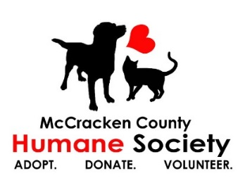 DATE OF APPLICATION_______________

NAME______________________________________ AGE*must be 18 yrs or older_________ DOB__________
ADDRESS_________________________________________________________________________________
CITY_____________________________________________ ZIP___________________________
PHONE_________________________________ E-MAIL__________________________________________ DRIVER’S LICENSE # _________________________________
EMERGENCY CONTACT:
NAME____________________________________ RELATIONSHIP___________________________________
HOME PHONE_____________________________ WORK PHONE___________________________________
CELL PHONE_______________________________ HOSPITAL CHOICE________________________________

*Do you have any allergies that might affect your work at MCHS? ____________________________________
*Date of last tetanus inoculation______________________ (Attach a copy to application)
*Do you have any family or friends that work here currently? YES___ NO___ If so, whom_________________
What is your preferred day/time to volunteer? ___________________________________________________
Some of our programs require that you use your own vehicle:
Do you have a valid driver’s license? YES NO
Is the vehicle covered by liability insurance? YES NO
Are you willing to transport animals or donations in your vehicle? YES NO

Please number the top three activities below that interest you the most, with #1 being of the highest interest to you.
______Clerical Help ______Community Outreach ______Special Events
______Photography/Videography ______Walking Dogs ______Bathing Cats and Dogs ______Fostering Animals ______Cleaning Kennels/Dog areas ______Cleaning Feline areas

How did you hear about the MCHS volunteer program?_____________________________________________
What made you interested in volunteering at MCHS?_______________________________________________
What special skills, training, or hobbies do you have to offer as a volunteer for MCHS?____________________
__________________________________________________________________________________________
How would you like to use these skills to help MCHS through volunteering?_____________________________ __________________________________________________________________________________________
Have you ever volunteered before? ________ If so, for what organization(s)? What was your role? __________________________________________________________________________________________
Are you still volunteering there? __________If not, why did you leave the organization? __________________________________________________________________________________________
Tell us about any companion animals in your life.__________________________________________________

I confirm that all information supplied on this application is true and correct.

Signature __________________________________________________ Date___________________________
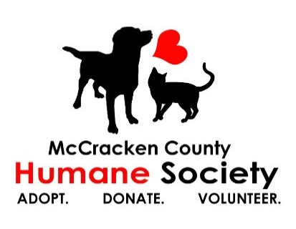
VOLUNTEER RELEASE FORM

I, ___________________________, hereby agree to accept a position as a volunteer worker for the McCracken County Humane Society, hereinafter referred to as MCHS, and in so doing, I agree to comply with all of the rules and regulations which may be established from time to time by MCHS. I understand that failure to do so may result in my immediate termination as a volunteer.
I acknowledge that my services are provided strictly on a volunteer basis, without any pay or compensation of any kind and without liability of any nature on behalf of MCHS. All services to be performed by me are at my own risk.
I recognize that in handling animals and performing other volunteer tasks there exists a risk of injury including but not limited to physical harm caused by the animals and/or transference of disease by the animals. On behalf of myself, my heirs, personal representatives and executors, I hereby release, discharge, indemnify and hold harmless MCHS, its agents, servants, and employees from any and all claims, causes of action, or demands, of any nature or cause, including costs and attorney fees incurred by MCHS in connection with the same, based on the damage or injuries which may be incurred or sustained by me or any companion animal I may be in contact with in any way connected with my services or as a result of my services for MCHS, including but not limited to animal bites, accidents, disease, or injuries.

DATE __________________ VOLUNTEER__________________________

I, ____________________________, understand that public relations is an important part of volunteering at the McCracken County Humane Society. On behalf of myself, my heirs, personal representatives and executors, I agree that the MCHS may use any photographs, videos, or other images taken of me for use in public relations efforts. I also agree to not post anything on social media pertaining to MCHS animals or procedures without the consent of MCHS management.
DATE___________________ VOLUNTEER__________________________

McCracken County Humane Society (known as MCHS) is always looking for compassionate and dedicated volunteers to join our team. We believe that everyone can make an impact on the lives of our shelter animals, whether that is directly or indirectly. See our list of volunteer opportunities.

Don't see your perfect volunteer role on this list? We will be sure to find an option that fits your schedule and makes the most of your time and talents.

​

HOW TO GET STARTED:

​

Fill out our online volunteer application

​

Complete inhouse orientation

​

Complete hands-on training

​

Volunteer and have fun!

​

TIME COMMITMENT:

​

There are no minimum requirements for volunteers. We appreciate any time that individual schedules will allow for.

​

AGE REQUIREMENTS:

​

We value all volunteers of all ages. Volunteers under the age of 18 must have a parent or guardian present when volunteering.

​

VOLUNTEER AS A GROUP:

​

If you have an idea for a group volunteer activity or a special request, please email MCHS at info@mccrackenhumane.org. Please be sure to include an ideal date, time, and general area of work you would like to help out in.

​

COMMUNITY SERVICE:

​

If you need to complete community service hours,

please call 270-443-5923.

​

HOW TO HELP OUTSIDE THE SHELTER:

​

If volunteering does not sound like it's for you but you are still looking for ways to help us here at MCHS, check out these other great options!

Wish List: MCHS is always in need of supplies! You can start your own wish list drive for MCHS with your school, friends, or community. You can find our Wish List on our website www.mccrackenhumane.org and also on Amazon/AmazonSmile and Chewy.com

ind our wish list here.

Become a Fan: Like and follow our Facebook, Instagram, Twitter, and Tiktok pages, then invite your family and friends to do it too. Like and share posts so they're seen by as many people as possible.

Facebook Fundraisers: Set up a Facebook fundraiser for birthdays or “just because” for your family and friends to participate in.

​

Donate Your Birthday: Request donations for MCHS instead of presents. Refer to our wish list for gift ideas.

​

Spread the Word: Educate your friends and family about the importance of spaying and neutering your pets to prevent overpopulation.

ADDITIONAL QUESTIONS
Contact us at 270-443-5923 or info@mccrackenhumane.org

